**实验四 Centos安装Mysql**

## 实验目的

掌握MYSQL安装和基本配置

## 实验步骤

1. 安装前的准备
2. 到官网下载mysql-8.0.16-2.el7.x86_64.rpm-bundle.tar
3. 下载Xshell 6，进行配置，然后连接. 通过rz命令，上传安装包到Centos 服务器。

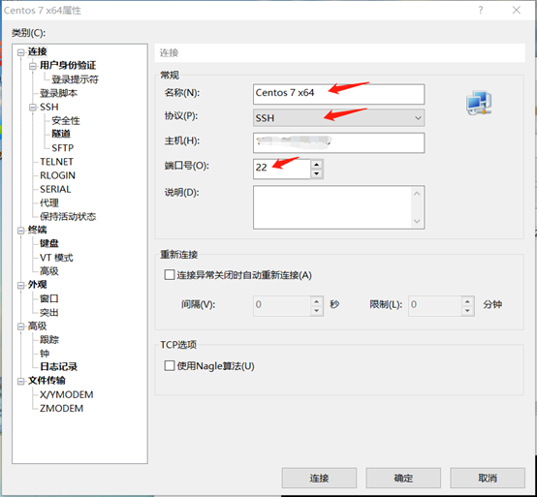

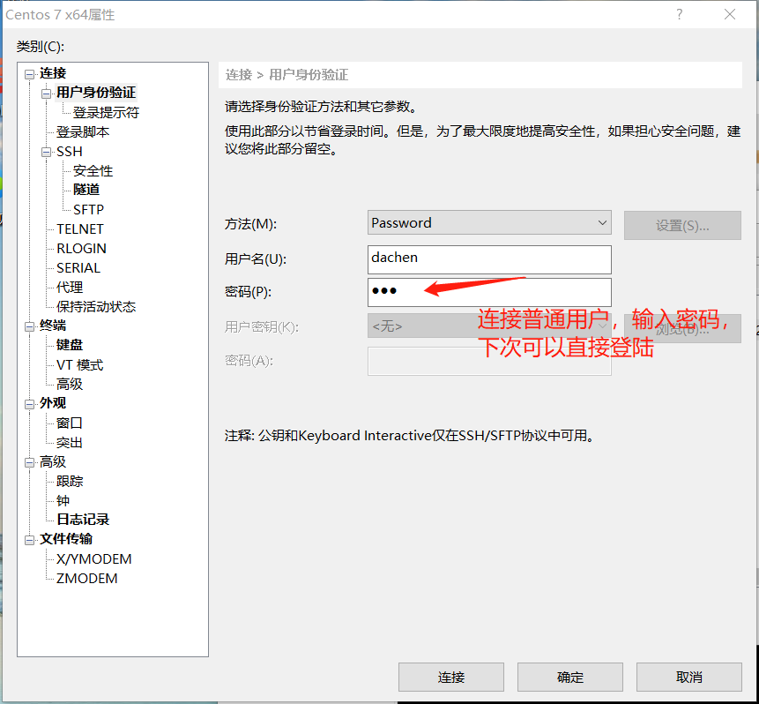

1. 清理工作

#列出所有被安装的rpm package

rpm -qa | grep mariadb

#卸载

rpm -e  --nodeps mariadb-libs-5.5.56-2.el7.x86_64

1. 安装

#在/home下创建文件夹

mkdir mysql

#解压安装包，解压后会生成多个文件

tar -xvf mysql-8.0.16-2.el7.x86_64.rpm-bundle.tar -C mysql

mysql-community-server-8.0.16-2.el7.x86_64.rpm

mysql-community-client-8.0.16-2.el7.x86_64.rpm

mysql-community-common-8.0.16-2.el7.x86_64.rpm

mysql-community-libs-8.0.16-2.el7.x86_64.rpm

mysql-community-devel-8.0.16-2.el7.x86_64.rpm

mysql-community-test-8.0.16-2.el7.x86_64.rpm

mysql-community-libs-compat-8.0.16-2.el7.x86_64.rpm

mysql-community-embedded-compat-8.0.16-2.el7.x86_64.rpm

#依次安装common->libs->client->server的rpm安装包

rpm -ivh mysql-community-common-8.0.16-2.el7.x86_64.rpm

rpm -ivh mysql-community- libs -8.0.16-2.el7.x86_64.rpm

rpm -ivh mysql-community- client -8.0.16-2.el7.x86_64.rpm

rpm -ivh mysql-community- server-8.0.16-2.el7.x86_64.rpm

#开启mysql服务

systemctl restart mysqld.service

#查看初始密码

cat /var/log/mysqld.log | grep password

#登陆

mysql -u root -p

#修改密码

ALTER USER 'root'@'localhost' IDENTIFIED BY '***'

#查看是否安装成功

show databases；